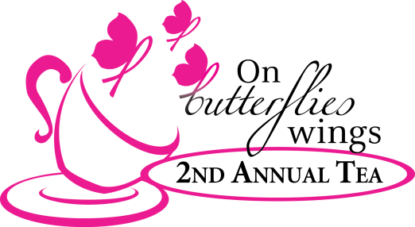
ON BUTTERFLIES WINGS 2nd ANNUAL TEA
Friday, October 23
Silent Auction: 11 a.m. – Noon
Tea Time: Noon - 1:30 p.m.
Winfrey Point at White Rock Lake
Online order form

EVENT REGISTRATION
Cost: $75 per ticket
Includes admission to event, full program of passionate speakers, tasty lunch, fabulous silent auction & more.

____ ticket(s) at $75 each. $_______ = Total cost of luncheon ticket(s)

CHANCE GIVEAWAYS (Need not be present to win)
Cost: 1 ticket for $25 or 5 tickets for $100
You choose which chance giveaway for each of your tickets.
- “Tiffany & Co” Frank Gehry® Fish pendant (Value: $1,125)
- “Night on the Town” including Dallas Mavericks tickets (2), one-night stay at the Ritz-Carlton Dallas, dinner at Victory Tavern (Value: 1,000)
- "His and Her" handmade boots - Old Gringo or Luchesse - your choice! (Value: $1,000)

____ ticket(s) at $25 each or 5 tickets for $100. $_______ = Total cost of chance giveaway ticket(s)

____ I am attending and will place my own tickets.
____ I am unable to attend. Please place my tickets in the below:
- “Tiffany & Co”: ____ ticket(s)
- “Night on the Town”: ____ ticket(s)
- "His and Her”: ____ ticket(s)

HEADS OR TAILS GAME
Cost: $20 for 2 chances to win
Prizes include a Tiffany & Co. necklace (Value: $1,100) or Tiffany & Co reversible tote (value: $675).

____ Yes! I would like to join the Heads or Tails game that will be played at the event!
Note: On Butterflies Wings will have your necklaces for you at check-in when you arrive.

BUTTERFLY RELEASE
Cost: $25 each
We will have a live Monarch butterfly release to conclude the event. It’s a moment you don’t want to miss!

____ butterfly(ies) at $25 each. $_______ = Total cost of butterflies to be released

ON BUTTERFLIES WINGS 2nd ANNUAL TEA
Friday, October 23
Silent Auction 11 a.m. – Noon
Tea Time: Noon - 1:30 p.m.
Winfrey Point at White Rock Lake
Online order form

SUMMARY
$_____ Total cost for luncheon ticket(s)
$_____ Total cost for Chance Giveaway ticket(s)
$_____ Total cost for Heads or Tails game
$_____ Total cost for butterfly release

TOTAL PURCHASE
$_____ Total purchase

I cannot attend but please accept my donation of $_______.

All contributions to On Butterflies Wings will be received, receipted and under the control of Communities Foundation of Texas (CFT), a 501(c) (3) nonprofit organization.

PAYMENT
___ I am paying by check. $________ made payable to On Butterflies Wings

___ I am paying by credit card: (circle one) MasterCard Visa American Express Discover

Card #: ___________________________________ Expiration: _____________ Security Code: ______

Name on card: ________________________________________________________________________

Billing address (including zip code): ________________________________________________________

Phone number (if we need to reach you regarding your registration) ________________________________

FORM SUBMISSION
Submit form and payment to: bastie@sbcglobal.net or 6840 Dartbrook, Dallas, TX 75254

CONTACT
Reservation Questions? Contact Sheri Bastie at bastie@sbcglobal.net or 469.951.0394

